Java Script

1. **why we need java script?**

Developers use JavaScript in web development to add interactivity and features to [improve the user experience](https://blog.hubspot.com/website/usability-vs-user-experience?__hstc=45788219.f59dd9dc41b459e719c5b4cd9a768a27.1646249529534.1646249529534.1646249529534.1&__hssc=45788219.1.1646249529535&__hsfp=1603130137&_ga=2.168554793.901349043.1646249529-1254543002.1646249529&hubs_content=blog.hubspot.com/website/what-is-javascript&hubs_content-cta=improve%20the%20user%20experience) and make the internet much more enjoyable.

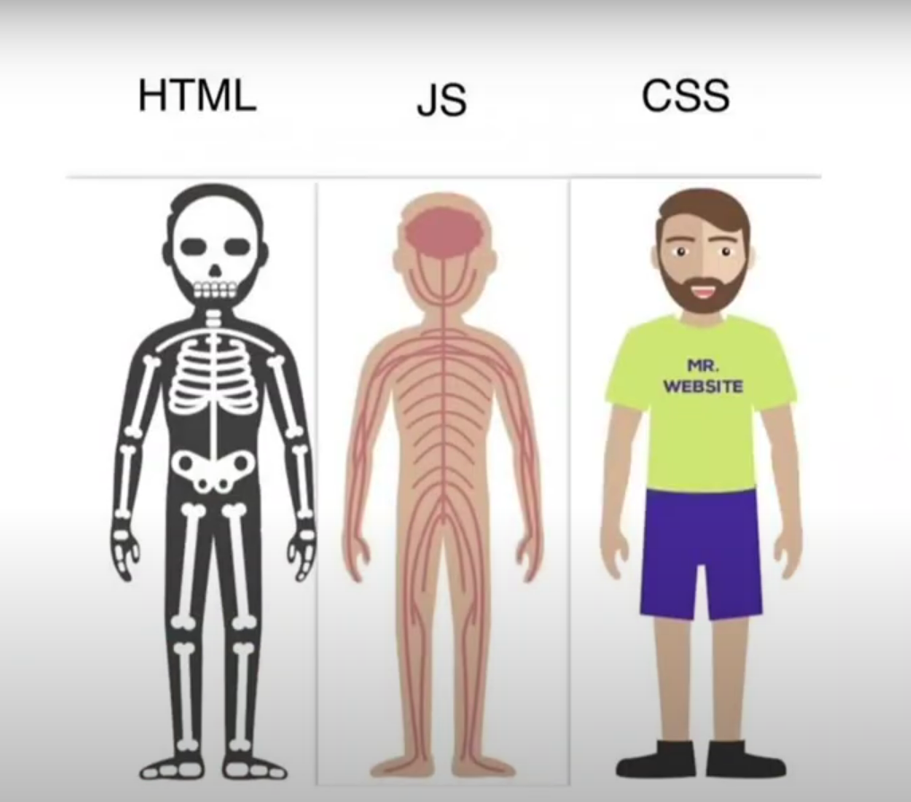

1. **History of java script?**

**Netscape programmer** named **Brendan Eich** developed a new scripting language in just **10 days**. It was originally called **Mocha**, but quickly became known as **LiveScript** and, later, **JavaScript**.

**What Is ECMAScript?**

When JavaScript was first introduced by Netscape, there was a war going on between all the browser vendors on the market at the time. Microsoft and several other browser vendors implemented their own versions of JavaScript (with different names and syntax) in their respective browsers. This created a huge headache for developers, as code that worked fine on one browser was a total waste on another. This went on for a while till they all agreed to use the same language (JavaScript) in their browsers.

As a result, Netscape submitted JavaScript to the [European Computer Manufacturers Association](https://www.ecma-international.org/) (ECMA) for standardization in order to ensure proper maintenance and support of the language. Since JavaScript was standardized by ECMA, it was officially named ECMAScript.

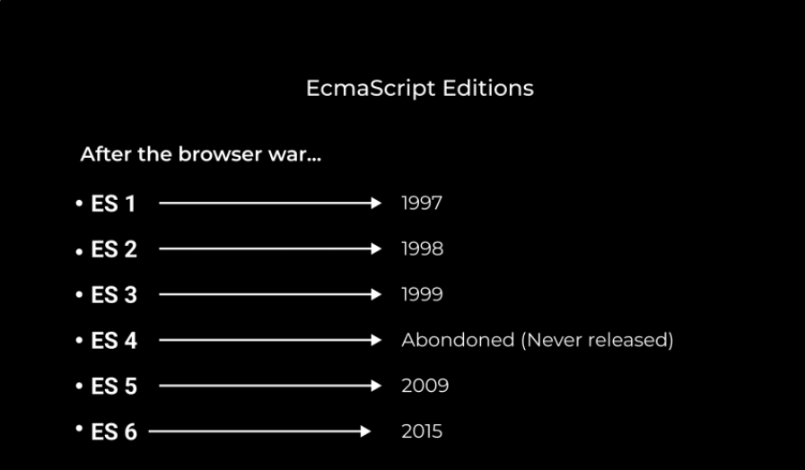

Originally, the name ECMAScript was just the formalization of JavaScript, but now languages like JScript and ActionScript are also based on the ECMAScript standard.

1. **What is java script?**

Java Script is a High level Programing Language that is primarly used to enhance the interactivity and dynamic behaviour of web sites

Java Script is also a light weight, cross platforms, Single threaded and High level Interpreted compiled programming language. It is knowns as Scripting Languages for websites.

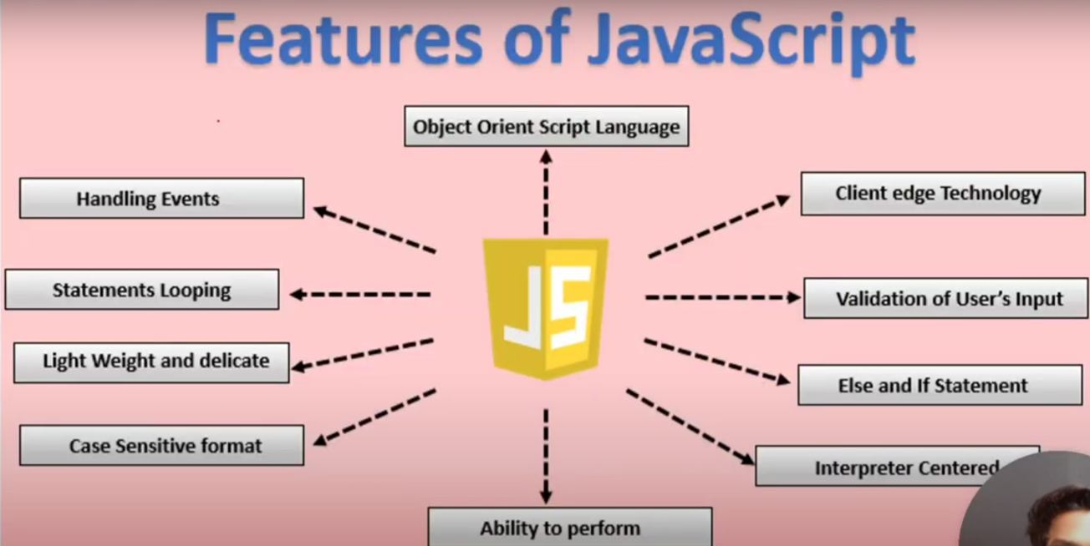

* **High-Level Language**

High-level languages are programming languages that are used for writing programs or software that can be understood by humans and computers. High-level languages are easier to understand for humans because they use a lot of symbols letters phrases to represent logic and instructions in a program. It contains a high level of abstraction compared to low-level languages.

* **Cross-platform**

It is a software or applications that can operate on multiple operating system

* **Single-theaded**

It is the only programming language that can run natively in a browser, making it an instrumental part of web development. However, one critical feature of JavaScript is that it is single-threaded. This means that it can only execute one task at a time.

* **Asynchronous**

how it can be used to effectively handle potential blocking operations, such as fetching resources from a server.

* **Synchronous**

Synchronous means the code runs in a particular sequence of instructions given in the program. Each instruction waits for the previous instruction to complete its execution.

* **Obeject Oriented**

It provides an overview of the basic concepts of OOP.

* **Scripting**

Scripting is used to automate tasks on a website. It can respond to any specific event, like button clicks, scrolling, and form submission. It can also be used to generate dynamic content. and JavaScript is a widely used scripting language.

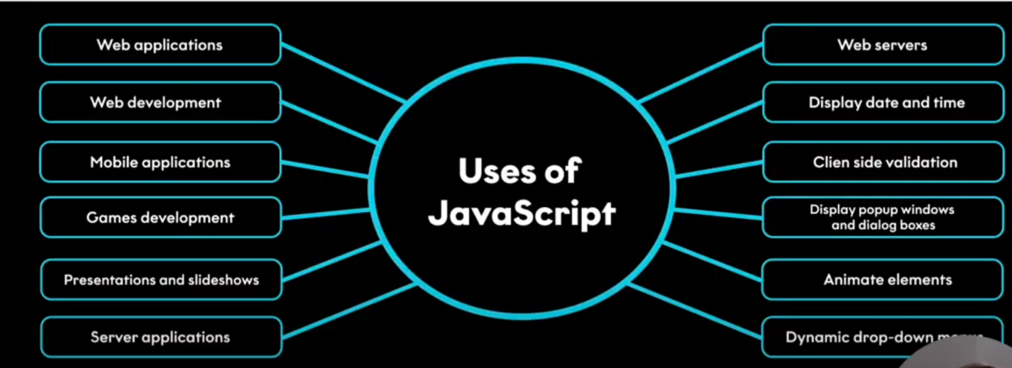

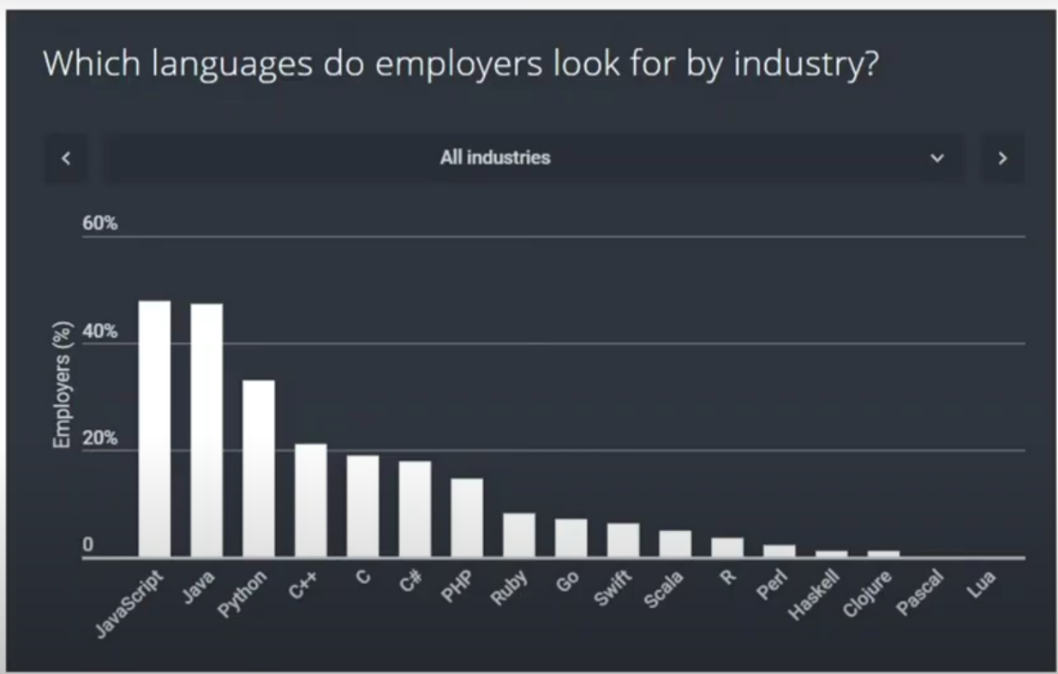

1. **What is Vanilla JavaScript**

The term vanilla script is used to refer to the pure JavaScript (or we can say plain JavaScript) without any type of additional library. Sometimes people often used it as a joke"nowadays several things can also be done without using any additional JavaScript libraries".

The vanilla script is one of the lightest weight frameworks ever. It is very basic and straightforward to learn as well as to use. You can create significant and influential applications as well as websites using the vanilla script.

The team of developers that created the vanilla JavaScript is continuously working on it to improve it and make it more useful for the web-developers.

1. **why JavaScript programming language?**

It supplies objects relevant to running JavaScript on a server. For if the server-side extensions allow an application to communicate with a database, and provide continuity of information from one invocation to another of the application, or perform file manipulations on a server. The useful framework which is the most famous these days is [**node.js**](https://www.geeksforgeeks.org/introduction-to-nodejs/).

1. **What is a JavaScript Engine?**

A JavaScript engine is a program that compiles JavaScript code and executes it. It is a software that runs inside a web browser or on a server that interprets JavaScript code and executes it. The engine is responsible for parsing the JavaScript code, compiling it into machine code, and executing it.

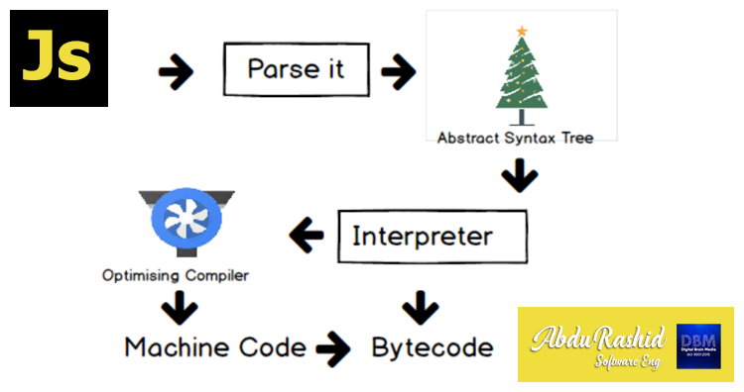

**Parsing**

The first stage of a JavaScript engine is parsing. It is the process of breaking down the source code into its individual components, such as keywords, variables, and operators. The parser creates a tree structure called the Abstract Syntax Tree (AST), which represents the structure of the code.

**Compilation**

The next stage is compilation. The compiler takes the AST and converts it into machine code. The machine code is optimized to run efficiently on the target platform. The compilation process includes several optimizations, such as inlining, loop unrolling, and dead code elimination.

**Execution**

The final stage is execution. The compiled code is executed by the JavaScript engine. The engine executes the code line by line, keeping track of variables and function calls. It also manages memory allocation and deallocation.

1. **Java script Run time environment?**

JavaScript works on a environment called **JavaScript Runtime Environment**. To use JavaScript you basically install this environment and than you can simply use JavaScript.

So in order to use JavaScript you install a **Browser** or **NodeJS** both of which are JavaScript Runtime Environment.

**call stack:**

The call stack is used to store information about function calls, including local variables, parameters, and the point of execution.

**Heap:**

The heap is a region of memory used for dynamic memory allocation. It stores objects, arrays, and other complex data structures that are created and managed at runtime.

**Web API:**

A Web API (Application Programming Interface) is a set of rules and tools that allows different software applications to communicate with each other over the web. It acts as an intermediary, enabling one application to interact with another application's data or functionality using standard web protocols, usually HTTP.

**Event loop:**

The event loop is a fundamental concept in asynchronous programming, especially in environments like JavaScript. It enables non-blocking operations, allowing code to execute asynchronously while ensuring that tasks are handled in an orderly manner. Here's a closer look at how synchronous and asynchronous operations interact with the event loop:

**Synchronous vs. Asynchronous**

1. **Synchronous:**

Synchronous operations are executed sequentially, one after the other. Each operation must complete before the next one begins.

1. **Asynchronous:**

Asynchronous operations allow code to execute without waiting for previous operations to complete. This is useful for tasks that involve waiting, such as network requests or timers.

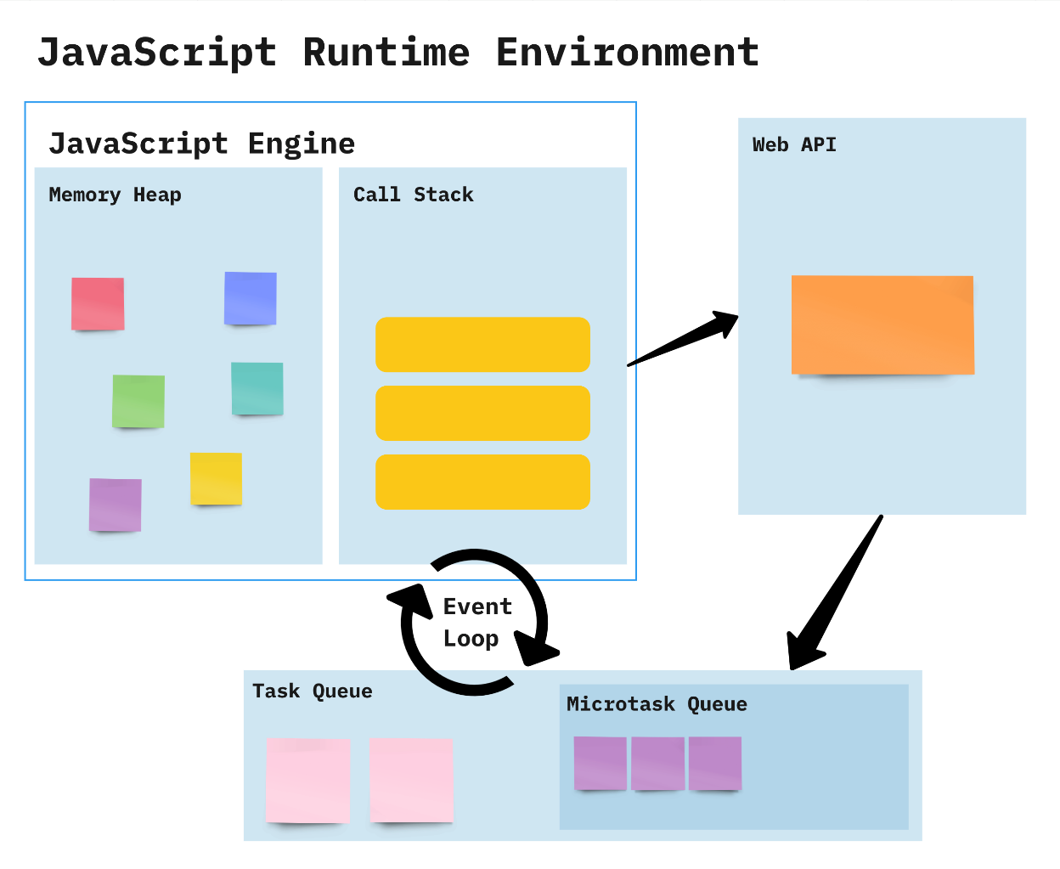

**How it Works:**

* Constantly checks whether or not the call stack is empty
* When the call stack is empty, all queued up Microtasks from Microtask Queue are popped onto the callstack
* If both the call stack and Microtask Queue are empty, the event loop dequeues tasks from the Task Queue and calls them
* Starved event loop

**Difference Between Compiler and Interpreter**

| **Compiler** | **Interpreter** |
| --- | --- |
| **Steps of Programming:**   * Program Creation. * Analysis of language by the compiler and throws errors in case of any incorrect statement. * In case of no error, the Compiler converts the source code to Machine Code. * Linking of various code files into a runnable program. * Finally runs a Program. | **Steps of Programming:**   * Program Creation. * Linking of files or generation of Machine Code is not required by Interpreter. * Execution of source statements one by one. |
| The compiler saves the Machine Language in form of Machine Code on disks. | The Interpreter does not save the Machine Language. |
| Compiled codes run faster than Interpreter. | Interpreted codes run slower than Compiler. |
| The compiler generates an output in the form of (.exe). | The interpreter does not generate any output. |
| Errors are displayed in Compiler after Compiling together at the current time. | Errors are displayed in every single line. |